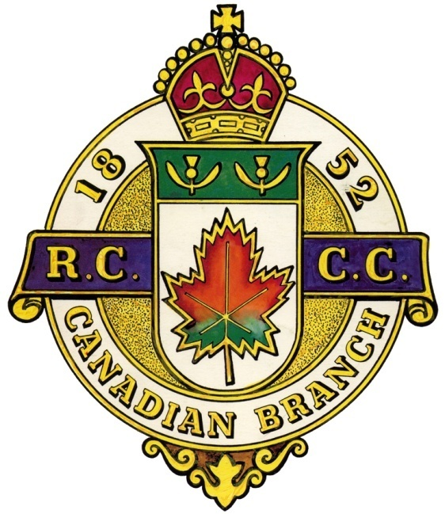
The CANADIAN BRANCH La FILIALE CANADIENNE
of the du
ROYAL CALEDONIAN CURLING CLUB
COUNCIL OF MANAGEMENT
ASSEMBLÉE DES ADMINISTRATEURS
Pointe Claire Curling Club, 250 Lanthier Ave., Pointe Claire, Quebec
Thursday, September 5, 2019 7:30 pm Jeudi le 5 Septembre 2019 1930h

AGENDA / ORDRE DU JOUR
- Call to Order / Ouverture de l’assemblée
Rob Kluke, President called the meeting to order at 7:35pm
- Opening Remarks / Bienvenue
Rob Kluke, President, welcomed all and thanked all for coming out.
- Invocation / Invocation
Rob Kluke, President, provided the Invocation.
Dear Lord, we thank you for watching over us this summer and we ask that you guide us during this upcoming season. May our rocks CURL JUST enough, may our sweepers SWEEP our rocks JUST enough and may we all ENJOY this wonderful game with friends old and new!
- Moment of Silence / Un moment de recueillement
Rob KLuke, President, called for a moment of silence for fellow curlers who passed away during the past year. Denny Charlebois from Ottawa Hunt and Golf Club, Grover Clare from Gananoque Curling Club and Julie Bridger from Brockville were noted.
- Notice of Meeting / Avis du convocation
It was noted that the Notice of Meeting had been duly distributed [On file as Doc#1].
- Special Guests / Invités spéciaux
Dan Cook, Past Branch President, Kemptville/Prescott.
- Roll Call / Presences
Rob Kluke, President, called upon the attendees to present themselves and their affiliations.
Gerry Yuskowski – Pointe Claire Brock MacDonald – Lachine
Jim Mastine – Lennoxville Steve Mariano – Pointe Claire
Robert Dods – Pointe Claire Rob Kluke – Kemptville
Dan Cook – Prescott/Kemptville
Matthew Kennerknecht – Glenmore
- Agenda / L’ordre du jour
Rob Kluke, President, confirmed that everyone received a copy of the Agenda. [On file as Doc#2].
Motion to accept agenda/ Adoption de l’ordre du jour
Motion proposed: Gerry Yuskowski
Seconded: Dan Cook
Passed unanimously.
- Mnutes of the last meeting (May 31, 2019)
Procès-verbaux de la dernière assemblée (le 3 Mai 2019)
Rob Kluke, President, confirmed that everyone received a copy of the Minutes for the May 31, 2019 meeting. [On file as Doc#3].
Motion to Approve the Minutes of the last meeting / Adoption des procès-verbaux de la dernier assemblée
Motion proposed: Jim Mastine
Seconded: Brock MacDonald
Passed unanimously.
- Business arising from the minutes
Affaires découlant des procès-verbaux
- New Presidents’ bonspiel – Brock MacDonald looking for location with Friday night, Saturday and Sunday draws; open format; could be cash event. North Grenville could – to be confirmed. Maybe in February.
Junior Open (relaunch DougWasher)?
Brock announced a new event – New Year’s Eve @ Lachine
- RCCC affiliation – followup email sent to RCCC with still no reply. Robert to follow up with Bill Duncan.
- Building Honourary Members nomination web page – Bob got information about the process from Bill Stevenson. Bob to send Steve form and other information.
- RCCC ties for Branch executives – Instead of using the RCCC ties, Brock suggested using forimprint to make Branch ties (gold colour with Branch crest logo imprint).
- 1,000th Quebec Challenge:
- Brock suggested 16 teams – 8 OVCA including 1 OVCA executive and 8 CQ including 1 CQ executive.
- minimum $240 per team which includes $60 Whitlock buffet (salad and pasta bars).
- Each team will get 4 meals plus 4 bags (blue bags for CQ teams, red bags for OVCA teams) plus 4 sets of 4 whiskey glasses.
- $720 budgetted for 2 bottles of Scotch and 2 bottles of Drambuie (1 each per draw) to fill the Cup with Rusty Nails.
- Steve to make bidding web page with minimum starting bid at $280. We will show the top bids for the 7 OVCA teams and 7 CQ teams. $20 minimum rebid. One winning team per club entry to maximize coverage. It will close 1 month before February 2nd event.
- We will invite Past Presidents, Gordon Committee, Governor Generals to join us for supper.
- Brock to send Steve poster for web site.
- OVCA AGM to be held Monday September 23.
Bob and Matthew will attend to represent Branch at it.
- Email introduction – Gerry Yuskowski to set up intro of Rob Kluke with Marc-Andre Robitaille.
- Correspondence/ Correspondance
Banner request – Bob sent Bill Woods Branch logo so he could get Governor Generals banners made.
- Regional Reports / Rapports régionaux
  - Montréal (District 1)
CQ AGM is set for September 15th. Brock will attend as part of ARCM voting delegation.
Glenmore and Baie D’Urfe are celebrating their 60th anniversaries. Lachine is celebrating their 125th.
  - Outaouais & Ontario (District 2)
OVCA AGM set for September 23rd.
  - South West (District 3)
None.
  - Mauricie (District 4)
There was no representative present – no report.
  - L’Estrie (District 5)
Jim Mastine reported. See Dwayne Fowler’s document 4 for report.
  - Others
No reports
    - Motion to accept the Regional Reports / Adoption des rapports régionaux
Motion proposed: Jim Mastine
Seconded: Brock MacDonald
Passed unanimously.
- Standing Committee Reports / Rapports des comités permanent
- Finance – Robert Dods
The Branch bank account stands at $3,351.53.
- Scheduling – Brock MacDonald
Montreal GGs set for Lachine.
Quebec GG finals set for Ormstown/Huntingdon January 4th.
GG finals set for Saturday, February 15th at Carleton Heights.
- Competitions – Brock MacDonald
Brock suggested that CQ teams pay $160 up from $120. OVCA teams pay $200 each. Brock suggests to bring CQ equal to OVCA entry fees over 2 years.
- Juniors – Kelso Mallette
No report.
- Gordon International – Don Robinson
Report to come after their meeting later this month.
- Quebec Challenge Cup – Jim Mastine
- New list on web.
- New binder that Bill Woods has needs to be updated.
- Other
None.
Motion to accept the Standing Committee Reports Reports / Adoption des rapports des comités permanent
Motion proposed: Brock MacDonald
Seconded: Jim Mastine
Passed unanimously.
- Other Committees / Autres comités
- Honorary Life Members
No applications.
- Historian
No report. Bill Woods suggested he will fill the role. Bob forgot to invite Bill – sorry!
- Past Presidents
No meetings held.
- Other.
No reports.
    - No motion is required to accept the Other Committee Reports/Aucun movement est exige accepter les Autres Rapports de Comites
- President’s closing Remarks
Rob Kluke thanked all for coming. Rob will approach Norht Grenville’s Dave Brown to become 2nd V.P.
- New Business / Affaires nouvelles
No new business.

- Next meeting / La prochaine réunion
Rob Kluke, President, proposed that the date of the next meeting will be Thursday, May 28th, 2020 at Pointe Claire Curling Club at 7 p.m.
- Adjournment / Fin de l’assemblée
The President then entertained a Motion to Adjourn, said motion offered by Brock MacDonald.
The meeting was adjourned at 9:39 pm.

